Establish a new directory, populate it with script files, initiate an empty repository on GitHub, convert the local directory into a Git repository, and link it to GitHub for pushing the code into the repository. Perform merge, rebase, stash commands in following GitHub repo.

**1.Establish a new directory (My-Project) and created 3 files (script1.py, script2.py, script3.py)**

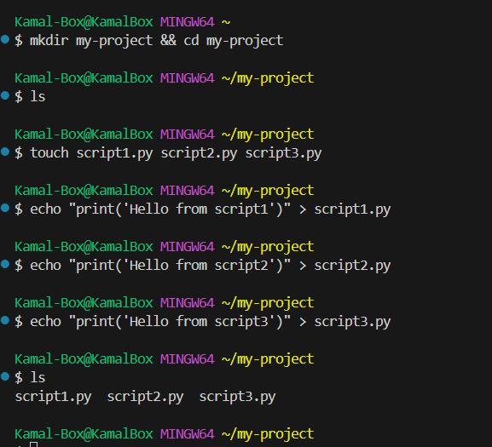

**2. Initialize a Local Git Repository**

**3. Create a New Repository on GitHub**

1. Go to GitHub web portal and login.

2. Create a new repository as “my-project”.

**4. Link the Local Repository to GitHub**

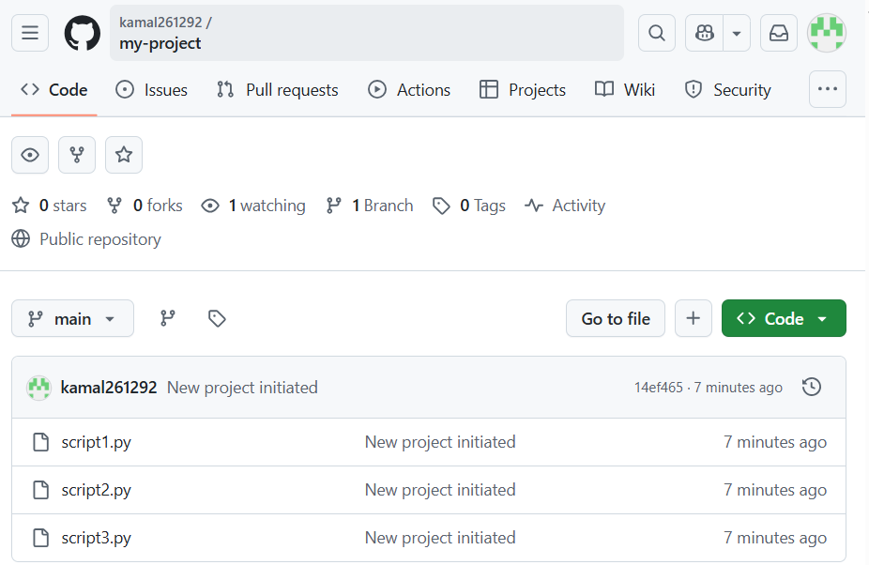

**5. Perform Git Operations (Merge, Rebase, Stash)**

Create a New Branch and Make Changes

Merge the Feature Branch into Main

Rebase the Feature Branch onto Main

Stash Changes

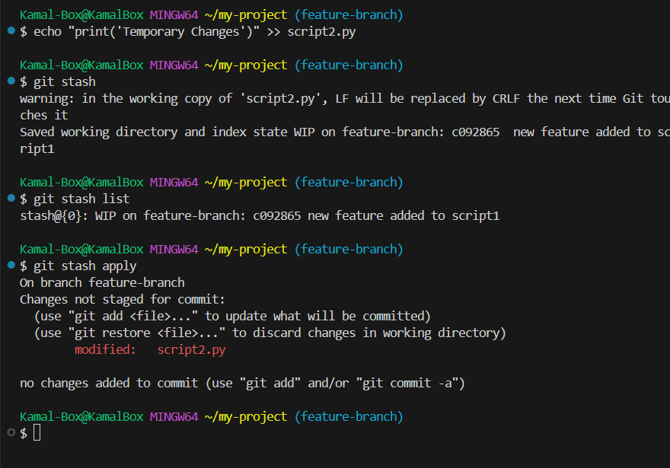

**Push Changes to GitHub**

